SELECT Java EE Based Server Manager

.NET Based server Manager can be installed in any windows OS, but .Net for Web-tier can be installed only on server OS like windows server 2008 R2 or 2012 R2.

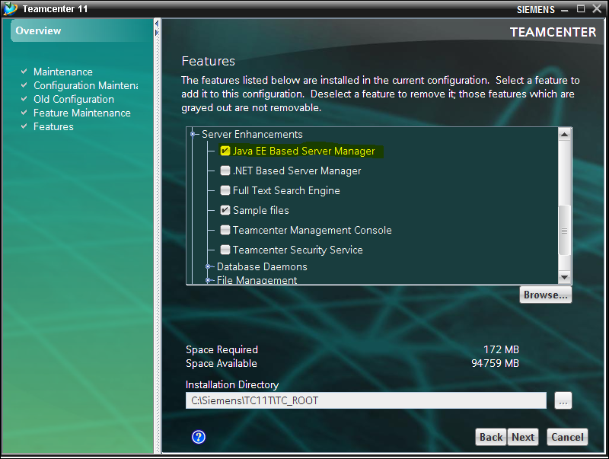

Enter the Teamcenter password for infodba user

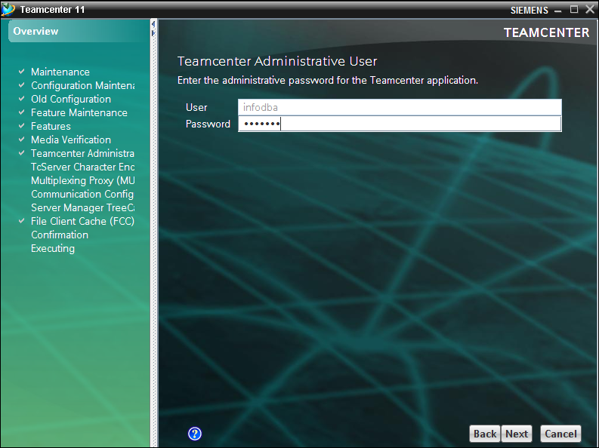

Give the Character Encoding based on the Database encoding.

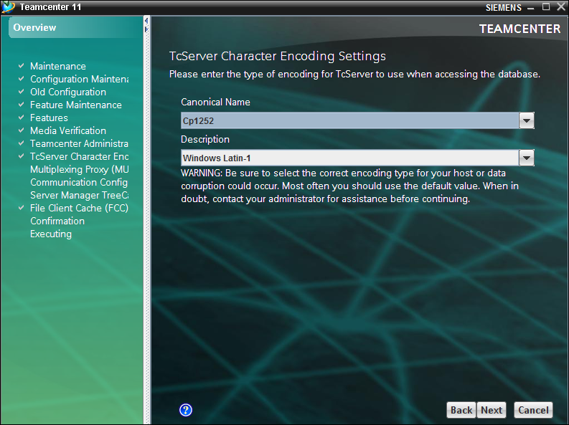

Keep the default ports

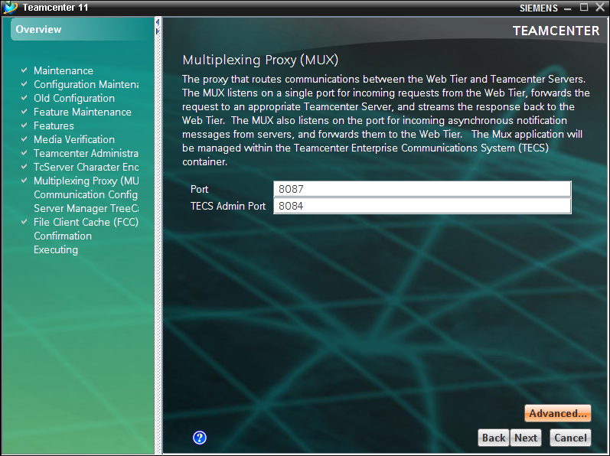

Modify the host name

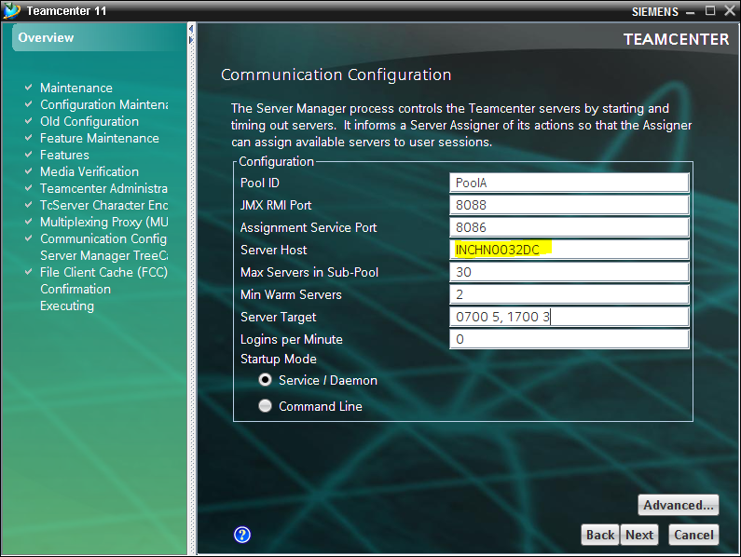

Modify the host name

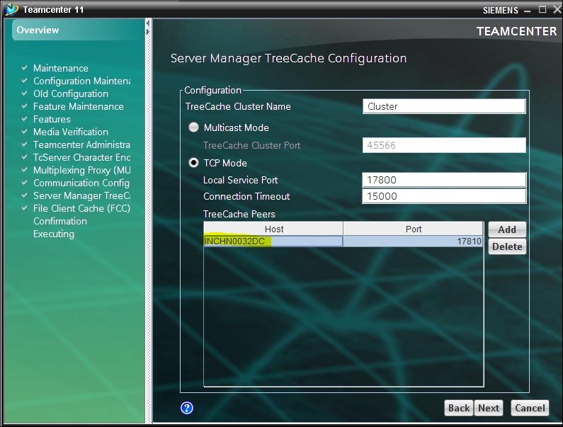

Enter the System password

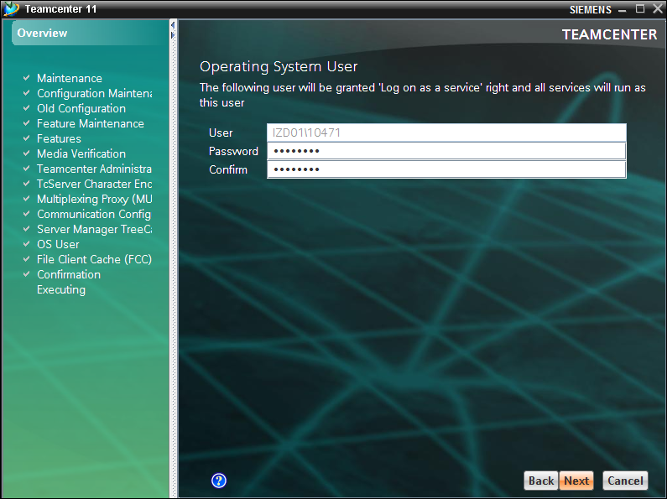

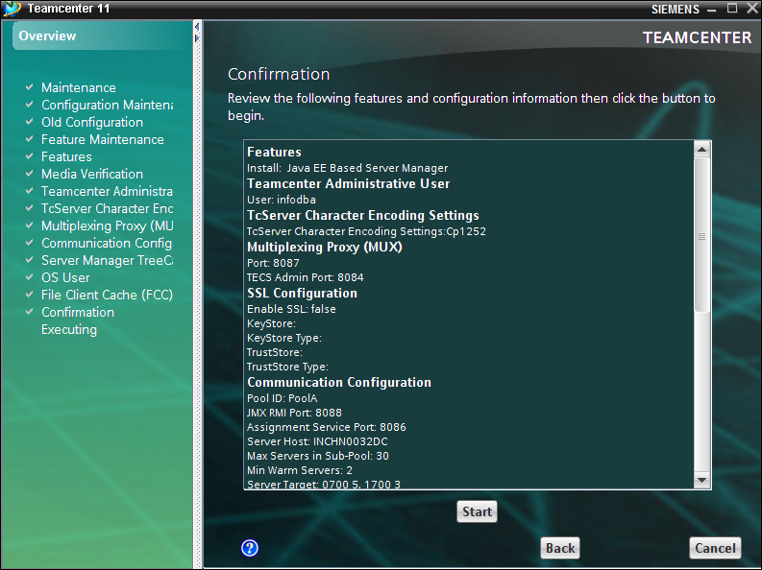

Web -tier

Run INSTALL_TCWEB.exe

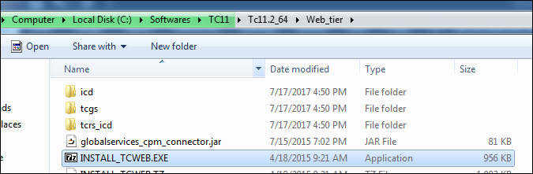

Create a new folder and extract into it.

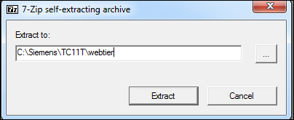

Launch insweb.bat

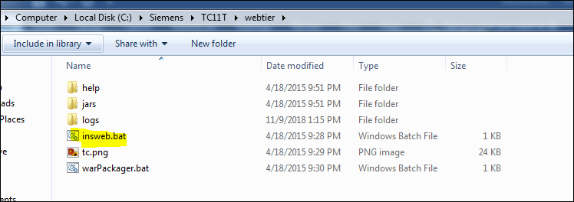

Copy ICD files

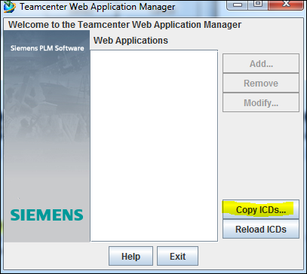

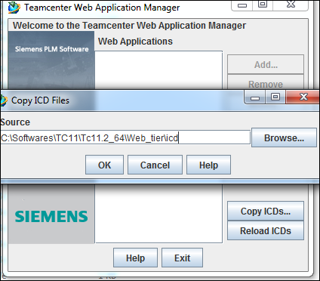

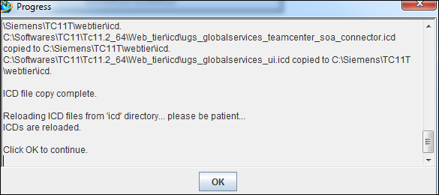

Select Add and modify the below

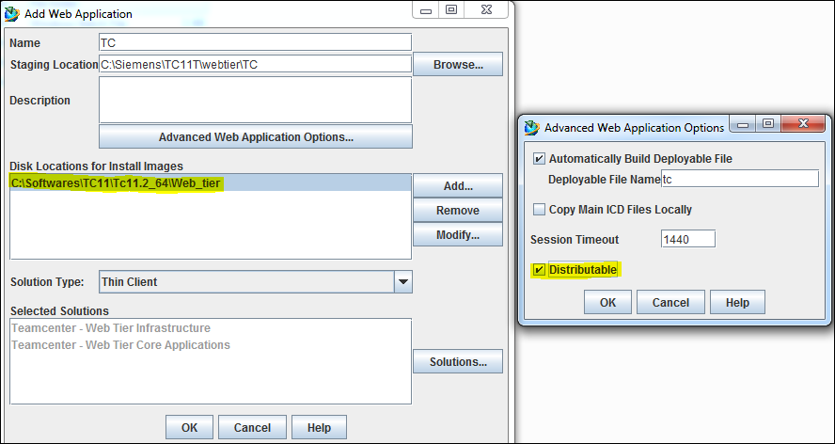

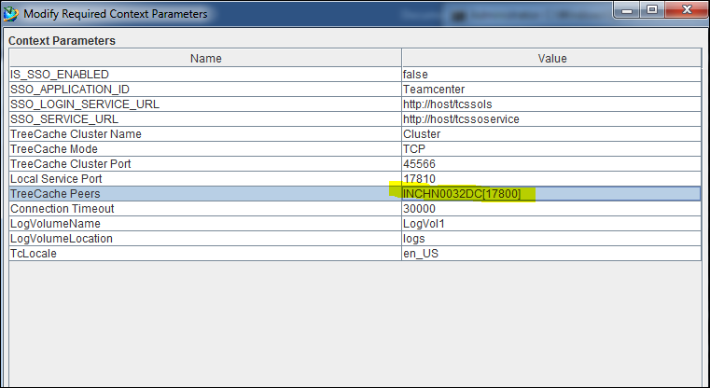

Select ok. War will get generated

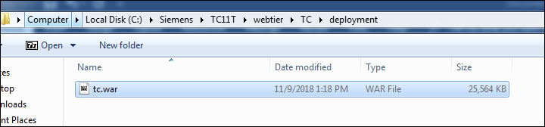

Copy the jboss and modify the standalone.xml

" \jboss-as-7.1.1.Final\standalone\configuration\standalone.xml"

Locate the subsystem element for the <subsystem xmlns="urn:jboss:domain:ee:1.0"> subsystem, and add the following global-modules element content:

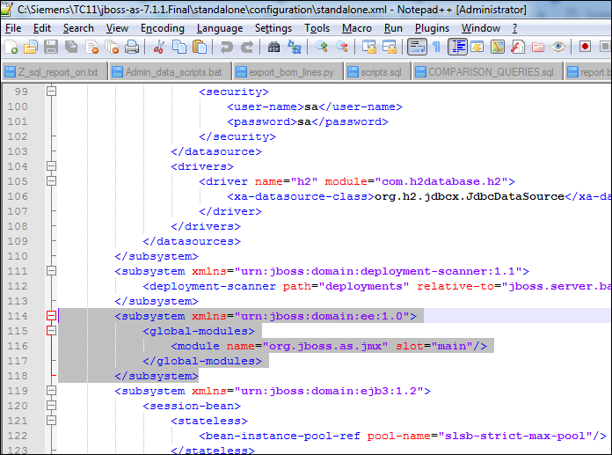

Locate the <subsystem xmlns="urn:jboss:domain:deployment-scanner:1.1"> element and add the deployment-timeout attribute with a value of 600 as follows:

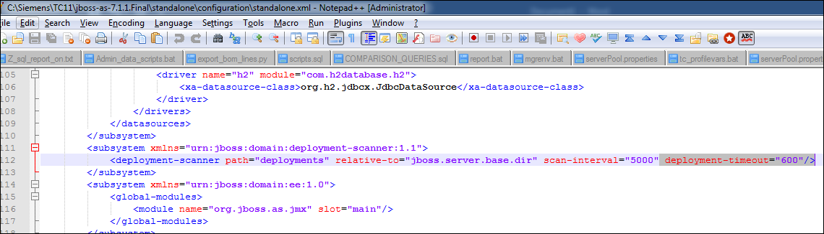

If you require IPv6 support, locate the interface element for the public interface and modify its contents as follows:

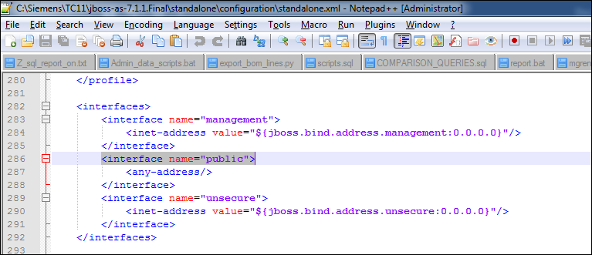

" \jboss-as-7.1.1.Final\modules\org\jboss\as\connector\main\module.xml"

Locate the dependencies element, and add the following module element:

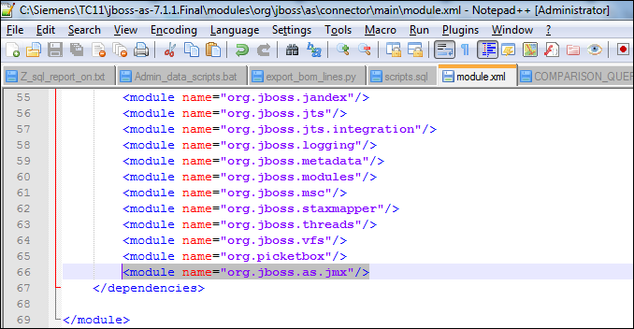

Deploy the war file in jboss

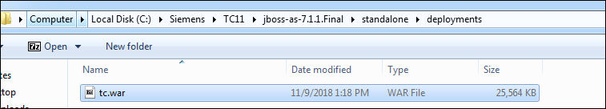

SET JAVA_HOME TO 1.7 in command prompt and start standalone.bat with binding argument hostname

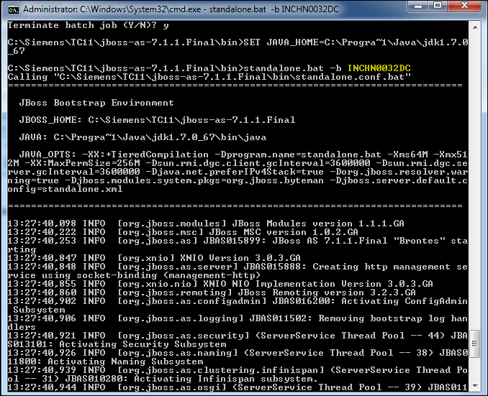

Connect the below URL

<http://hostname:8080/tc/webclient>

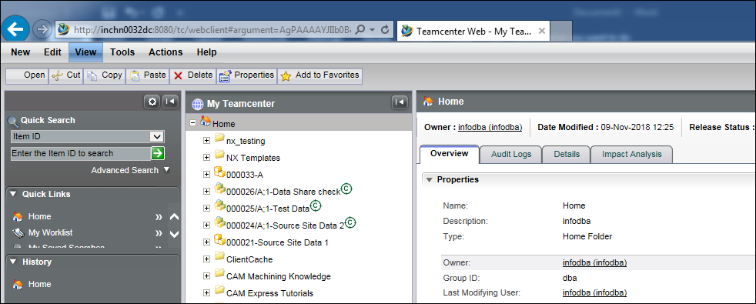

To enable Server Manager Monitor

Enable the port for JMX_HTTP_ADAPTOR_PORT

